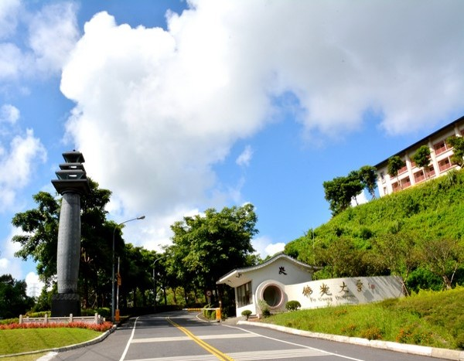
FO GUANG UNIVERSITY (FGU)
2024 Spring
EXCHANGE STUDENTS PROGRAM
IN TAIWAN (FGU)
The online link of application: t.ly/4PF8O

Table of Contents

Application----------------------------------------------------------------2
FGU Calendar-Regular Courses------------------------------------3
FGU Calendar-Chinese Language Instruction Center--------3
CLIC 2024 Calendar----------------------------------------------------4
Dormitory------------------------------------------------------------------5
Tuition & Personal Expense------------------------------------------6
Credit-----------------------------------------------------------------------8
Insurance------------------------------------------------------------------8
Medical Examination Requirements--------------------------------9
Attachment1 Nomination List-------------------------------------------12
Attachment2 Coverage of Insurance----------------------------------13
Attachment3 Get insurance at FGU-------------------------------14

Application
No. | Item | Deadline | Description
1 | Nomination list | 2024.FEB.07 | Please fill in the list and email it to oica@gm.fgu.edu.tw  The list should be filled and emailed by the office coordinator at your home institution.
2 | Google Online Application Form | 2024.FEB.16 | Please fill out the google online form to complete application.  The online link of application form:  t.ly/4PF8O  please upload the requirements (jpg or pdf) as below:  - Profile photo  - Certificate of Enrollment in English  - Transcript of last semester in English  - A copy of Medical and Accident Insurance (please see page.13 to confirm the coverage)  - Copy of Passport  - Medical Examination Requirements for short-term Students(Form C)-  Please see page.9 to confirm the details. There are 3 forms.
3 | Sending Acceptance Letter | 2024.FEB.23 | We will email acceptance letter to the office coordinator at your home institution.  The acceptance Letter would be one of requirements for a visa.

FGU Calendar-Regular Courses
No. | Item | from ~to~ | Description
1 | Regular courses of  2024 Spring  *Course information please find the link below for reference:  https://reurl.cc/28q6y6 | fm. 2024.Feb.26th  to 2024.Jun.28th. | Our regular courses are Chinese as a medium of instruction. If exchange students would like take the courses, please submit a certificate of TOCFL :A2 or higher level.
2 | 2024 Summer vacation | fm. 2024.July.  to 2024.Sep
FGU Calendar-Chinese Language Instruction Center (CLIC)
No. | Item | from ~to~ | Description
1 | 2024 Spring Season  (12weeks) | fm. 2024.Feb.26th  to 2024.May.24th | It’s unnecessary to submit any proofs of Chinese level.  language Course information please find the link below for reference:  https://reurl.cc/MXE6Qn
2 | 2024 Summer Season  (12weeks) | fm. 2024.May.27th  to 2024.Aug.23th
3 | Airport pick-up Service of CLIC |  | until further notice
4 | Last Arrival date of 2024 Spring | 2024.Feb.26th
※Important notice, CLIC tuitions must pay by exchange students.

CLIC 2024 Calendar
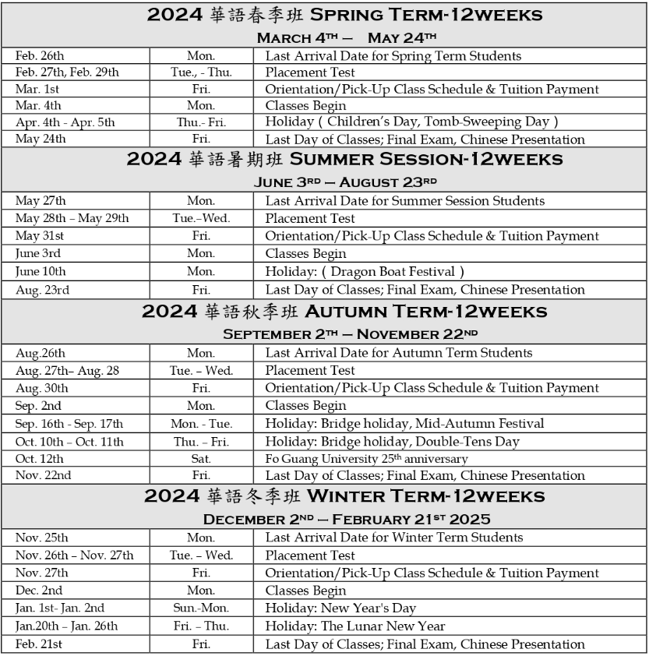

Dormitory
Item | Description | Photos
Public Space | Lounge with TV*1,  Reading room*2.  Laundry, Pantry, coin-operated washer, dryer on every floor.  Security office | 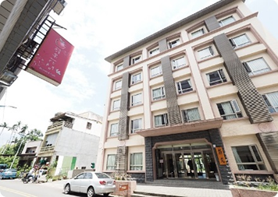  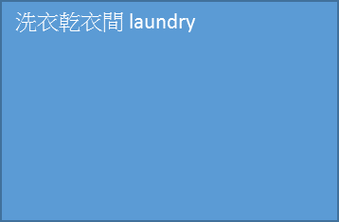  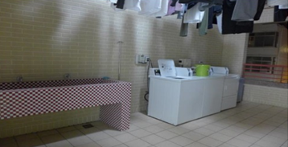  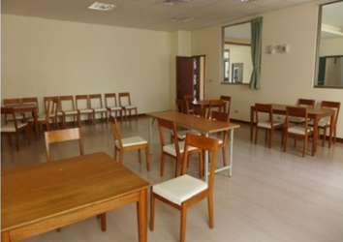  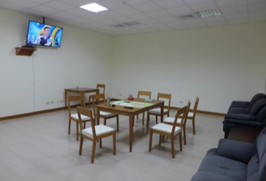
Room type and the charge  4人房 Quadruple room  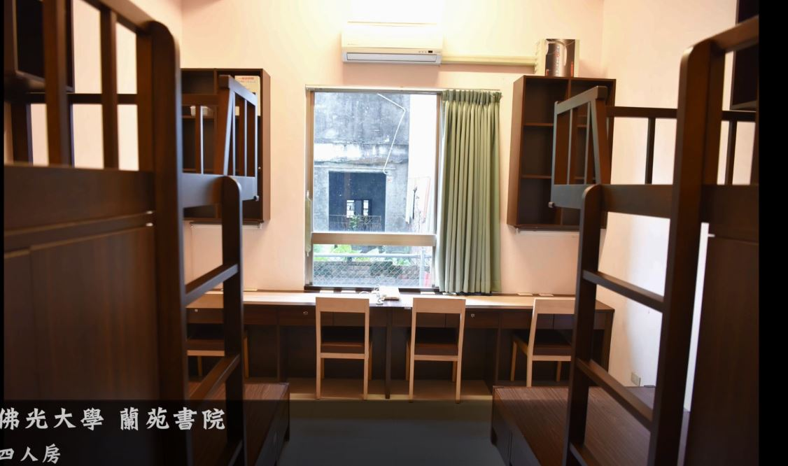 | Quadruple room:  NT$8,750 per semester  Deposit:  NT$2,000(Refunding to you when check out)  Facilities: bed,desk,closet,air conditioner,bathroom,network socket for laptop or desktop
Notice  Attention: Regarding the room type, we will consider your requirement first and arrange it as much as possible. However, the final result will still depend on the actual situation. | - The dormitory fee is not including summer and winter vacation. If you would like to extend stay in winter or summer vacation, should apply at the end of semester and pay the extra fees.  - Waiver of Dormitory Fee: Depends on the MOU between your home institution and FGU.  However, summer and winter vacation are not included.
Tuition & Personal Expense
Item | Description
Tuition of Regular courses | Free
Tuition of CLIC | Placement test:NT$500(If you have never learned Chinese, don’t need to take the test)  Please see the tuition list of CLIC as below.  - (Waiver of Tuition: Depends on the MOU between your home institution and FGU.)
Dormitory | Please see the page.3
Meals | NT$250/day on the average
cost-of-living | NT$10,000~17,000/month on the average
The tuition list of CLIC
Class | Attendance | hours per week | Charge per hour | Spring term/Summer season/  Fall term/Winter term  (12weeks per term)
individual | 1 person | 15 | NT$600 | NT$108,000
 |  | 10 |  | NT$72,000
 |  | 8 |  | NT$57,600
 |  | 6 |  | NT$43,200
 |  | 4 |  | NT$28,800
 |  | 2 |  | NT$14,400
group | 2-3 persons | 15 | NT$320 | NT$57,600
 |  | 10 |  | NT$38,400
 |  | 8 |  | NT$30,720
 |  | 6 |  | NT$23,040
 |  | 4 |  | NT$15,360
 |  | 2 |  | NT$7,680
 | 4-6 persons | 15 | NT$220 | NT$39,600
 |  | 10 |  | NT$26,400
 |  | 8 |  | NT$21,200
 |  | 6 |  | NT$15,840
 |  | 4 |  | NT$10,560
 |  | 2 |  | NT$5,280
 | 7-10persons | 15 | NT$200 | NT$36,000
culture | no limit | - | NT$200 | -
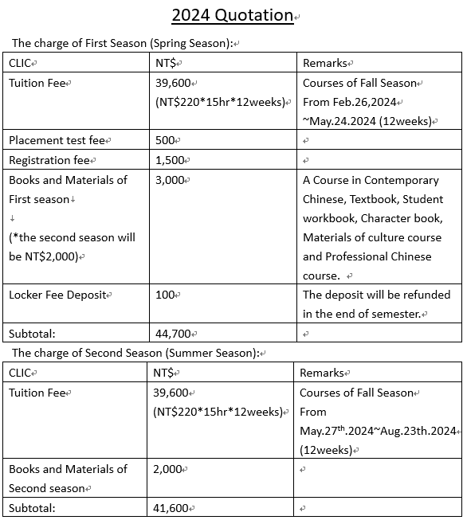
Credit
Item | Description
Regular courses  (Please submit a certificate of TOCFL :A2 or higher level) | min credit: 0 credit/semester  (you can take courses of CLIC only)  max credit: 27 credit/semester
Chinese language instruction center  (CLIC) | If you complete the courses, we are going to issue certificate of completion instead of credit.
Notice | You can also take regular course as long as it won’t overlap with Chinese language courses (CLIC).
Insurance
The insurance is optional. You can get insurance in your home country or in Taiwan
Item | Description
Get insurance in your home country | You can take out an insurance in your country.  Please see the attachment2 for reference.
Get insurance in Taiwan (FGU) | Please see the attachment3. Our staff of CLIC will charge you NT$3,000 to take out insurance for you.

Medical Examination Requirements
短期研修健康檢查表（丙表）  Medical Examination Requirements for Short-Term Students（Form C）  (參考用)(For Reference Only) | 檢查日期 ____/____/____  (年) (月) (日)  Date of Examination ____/____/____  (Ｍ) (Ｄ) (Ｙ)

基 本 資 料 (Basic data)
姓 名 | ： |  |  |  |  |  |  |  | 性別 | ： | □男Male |  |  | □女Female
Name |  |  | ____________________ |  |  |  |  |  | Sex
國籍 |  | ： |  |  |  |  |  |  | 護照號碼 |  |  | ：
Nationality |  |  | ____________________ |  |  |  |  |  | Passport No. |  |  |  | ____________________
出生年月日 |  | ： | ––––– | / | ––––– | / | –––––
Date of Birth

檢 查 項 目 (Items required)
A. 麻疹及德國麻疹(風疹)之抗體陽性檢驗報告或預防接種證明（Proof of Positive Measles and Rubella Antibody Titers or Measles and Rubella Immunization Certificates）：
a.抗體檢查Antibody Test
麻疹抗體Measles antibody titer □陽性 Positive □陰性 Negative □未確定（Equivocal）
德國麻疹(風疹)抗體Rubella antibody titer □陽性 Positive □陰性 Negative □未確定（Equivocal）
b.預防接種證明 Immunization Certificate (含疫苗名稱、接種日期、接種單位或醫師簽章。如檢附幼時接種紀錄，其接種年齡必須大於1歲。)
(The certificate must include information such as the date of immunization, and the name of the hospital or clinic administering the vaccine or the signature of the physician administering the vaccine. If the childhood immunization record is submitted, it is important to include the record of the vaccines administered only after one year of age.)
□麻疹預防接種證明Measles Immunization Certificate
□德國麻疹(風疹)預防接種證明Rubella Immunization Certificate
c. □經醫師評估，有接種禁忌者，暫不適宜接種。(Having contraindications, not suitable for vaccination)
B. 胸部X光檢查肺結核（ChestＸ-Ray for Tuberculosis）：
X光發現(X-ray Findings)：
判定(Results)：
□合格(Passed) □疑似肺結核(TB Suspect) □須進一步診斷( Pending) □不合格(Failed)
□孕婦免驗 (Maternity Exemption)

備註(Note)：
一、本表為外籍學生、大陸及港澳地區學生來臺停留研修之健康檢查項目表。本表僅供參考用，學生可分別檢具預防接種證明及胸部X光檢查報告。This form lists the required medical examination items for students applying for short-term study in Taiwan. This form is only used for reference. Students may submit a copy of immunization certificates and the chestＸ-ray report instead of completing this form.
二、根據以上對 先生/女士/小姐之檢查結果為
□合格 □不合格 □須進一步檢查
Results：According to the above medical report of Mr./Mrs./Ms. , he/she
□has passed the examination □has failed the examination □needs further examination.
 | ： |  | （Name ＆ Signature）
(Chief Medical Technologist)
 | ： |  | （Name ＆ Signature）
( Chief Physician )
 | ： |  | （Name ＆ Signature）
( Superintendent )
日期（Date）： / /
麻疹及德國麻疹(風疹)之抗體陽性檢驗報告或預防接種證明(二擇一)
Proof of Positive Measles and Rubella Antibody Titers or Measles and Rubella Immunization Certificates (alternative)

姓 名 | ： |  |  |  |  |  |  |  | 性別 | ： | □男Male |  |  | □女Female
Name |  |  | ____________________ |  |  |  |  |  | Sex
國籍 |  | ： |  |  |  |  |  |  | 護照號碼 |  |  | ：
Nationality |  |  | ____________________ |  |  |  |  |  | Passport No. |  |  |  | ____________________
出生年月日 |  | ： | ––––– | / | ––––– | / | ––––
Date of Birth
a.抗體檢查Antibody Test
麻疹抗體Measles antibody titer
□陽性 Positive □陰性 Negative □未確定（Equivocal）
德國麻疹(風疹)抗體Rubella antibody titer
□陽性 Positive □陰性 Negative □未確定（Equivocal）
b.預防接種證明 Immunization Certificate (含疫苗名稱、接種日期、接種單位或醫師簽章。
如檢附幼時接種紀錄，其接種年齡必須大於1歲。)
(The certificate must include information such as the date of immunization, and the name of the hospital or clinic administering the vaccine or the signature of the physician administering the vaccine. If the childhood immunization record is submitted, it is important to include the record of the vaccines administered only after one year of age.)
□麻疹預防接種證明Measles Immunization Certificate
□德國麻疹(風疹)預防接種證明Rubella Immunization Certificate
c. □經醫師評估，有接種禁忌者，暫不適宜接種。(Having contraindications, not suitable for vaccination)

 | ： |  | （Name ＆ Signature）
(Chief Medical Technologist)
 | ： |  | （Name ＆ Signature）
( Chief Physician )
 | ： |  | （Name ＆ Signature）
( Superintendent )

檢查日期（Date of Examination）： / /

胸部X光檢查肺結核報告
ChestＸ-Ray for Tuberculosis Report
姓 名 | ： |  |  |  |  |  |  |  | 性別 | ： | □男Male |  |  | □女Female
Name |  |  | ____________________ |  |  |  |  |  | Sex
國籍 |  | ： |  |  |  |  |  |  | 護照號碼 |  |  | ：
Nationality |  |  | ____________________ |  |  |  |  |  | Passport No. |  |  |  | ____________________
出生年月日 |  | ： | ––––– | / | ––––– | / | ––––
Date of Birth

X光發現(X-ray Findings)：
判定(Results)：□合格(Passed) □疑似肺結核(TB Suspect)
□須進一步診斷( Pending) □不合格(Failed)

 | ： |  | （Name ＆ Signature）
( Chief Physician )
 | ： |  | （Name ＆ Signature）
( Superintendent )

檢查日期（Date of Examination）： / /

Attachment1

【Fo Guang University】Exchange Student Nomination List for Entry in 2024 Spring
No. | Name in English | Name in Chinese | Nationality | Gender  (M/F) | Birthdate  (Year/Month/Day) | Home University Name | Major area of Study at your home institution | Length of Exchange Study  (1 Semester / 1 Year) | Student's Personal Email Address
ex. | Kim Soo Hyun | 金秀賢 | Korea | M | 1998/12/19 | ○○ University | Department of Psychology | 1 year | pinfish1219@gmail.com
1
2

Signature of office coordinator: ___________________________

*The list should be filled and emailed by the office coordinator at your home institution.
*Please Email the Nomination list by 2024.FEB.07 to oica@gm.fgu.edu.tw

Attachment2
Get an insurance in your home country. The coverage is for reference.
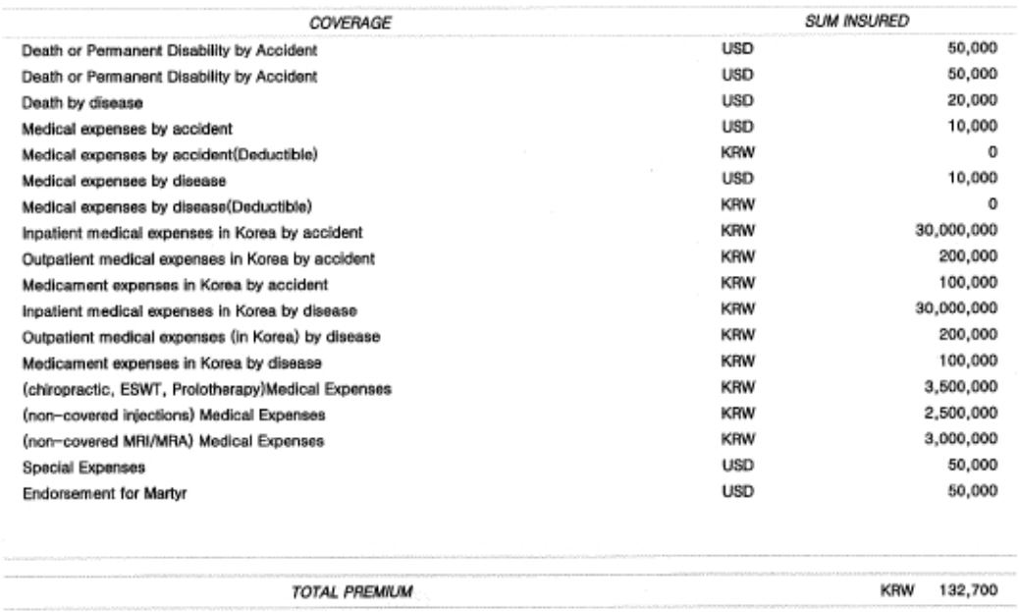

Attachment3
We will charge you NT$3,000 for you insurance plan.
